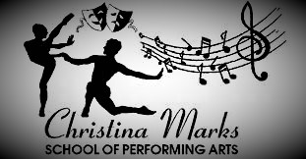

Dear Parents/Guardian,

I, Christina will be offering the children of Billinghurst Primary Academy Cheerleading classes every Monday afterschool.

Class times will run from 3:30-4:30

Why Join:
- Personal Growth: Cheerleading provides opportunities to build confidence, leadership, and resilience.
- Fun & Camaraderie: You’ll have the chance to be part of a close-knit, supportive team where everyone is encouraged to contribute and grow together.
- Skill Mastery: Whether you are a seasoned athlete or new to cheerleading, there are plenty of opportunities for skill development, from jumps and stunts to cheers and chants.
- School Spirit: Cheerleading offers a fun way to show school pride and boost morale at games and events, while making a difference in the community.
We welcome students of all backgrounds and experience levels. Whether you're interested in cheering for school events, enhancing your athleticism, or simply enjoying the camaraderie of a spirited team, the Christina Marks School of Performing Arts is the place for you.
We look forward to welcoming your child to this exciting new adventure!
Open to all ages.
To register and secure please follow the link below.

https://christina-marks-sopa.classforkids.io

We encourage you to sign up soon as spots are limited!

christinamarksschoolofperformingarts@hotmail.com
07525850232

Yours Sincerely,

Christina Knight

